10 The Next Room
If you have been following along from our last lesson, you will have noticed, that we have indeed gotten to the next room, but this room had no hero. We could have dragged the hero out of the Asset browser and placed him into this room prior to running it, but that is not exactly the best way to handle this, and our hero will be tied to some behavior, that we may not want for every room. So, instead of that we will be updating the code in the hero. First thing that we want to do is to make him persistent. Persistent means that he will stay there even though we are changing from room to do, which is exactly what we want him to do.


To make him persistent write this code into the hero object. We will be placing this code in the Create event, since as soon as this guy shows up anywhere, or is created, we want him to persist to also be in the next place we want to go.
persistent = true;

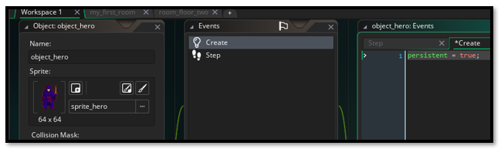

Spawning the Hero
Now we also want to spawn (*create) this new hero into the room. The only thing we are doing now when the hero is crashing into the room, is creating the room. So, we need to change our hero’s step code a bit. We not only want to create the room, but we also need to have our hero in it. So, change out the hero_object step event to be this new code, with some hero spawning code added to it.

// Movement input
var move_x = keyboard_check(vk_right) - keyboard_check(vk_left);
var move_y = keyboard_check(vk_down) - keyboard_check(vk_up);

var spd = 4;
var dx = move_x * spd;
var dy = move_y * spd;

// --- Attempt full diagonal move first ---
if (dx != 0 || dy != 0) {
var nx_left = bbox_left + dx;
var nx_right = bbox_right + dx;
var ny_top = bbox_top + dy;
var ny_bottom = bbox_bottom+ dy;

var hit_diag =
wall_is_solid(nx_left, ny_top) ||
wall_is_solid(nx_right, ny_top) ||
wall_is_solid(nx_left, ny_bottom) ||
wall_is_solid(nx_right, ny_bottom);

if (!hit_diag) {
x += dx;
y += dy;
} else {
var hit_x =
wall_is_solid(bbox_left+dx, bbox_top) ||
wall_is_solid(bbox_right+dx, bbox_top) ||
wall_is_solid(bbox_left+dx, bbox_bottom) ||
wall_is_solid(bbox_right+dx, bbox_bottom);

if (!hit_x) {
x += dx;
}

var hit_y =
wall_is_solid(bbox_left, bbox_top+dy) ||
wall_is_solid(bbox_right, bbox_top+dy) ||
wall_is_solid(bbox_left, bbox_bottom+dy) ||
wall_is_solid(bbox_right, bbox_bottom+dy);

if (!hit_y) {
y += dy;
}
}
}

// --- Door collision ---
if (place_meeting(x, y, Object_Door)) {

// Store spawn position for next room
global.hero_spawn_x = 64; // adjust as needed
global.hero_spawn_y = 128; // adjust as needed

room_goto(room_floor_two);
}

// --- Sprite switching ---
if (move_y < 0) sprite_index = sprite_hero_back;
else if (move_x > 0) sprite_index = sprite_hero_right;
else if (move_x < 0) sprite_index = sprite_hero_left;
else sprite_index = sprite_hero;

Adding a room Start Event
This is in the hero object, but you need to drill down to find it, it will be located under the Other option in the menu.
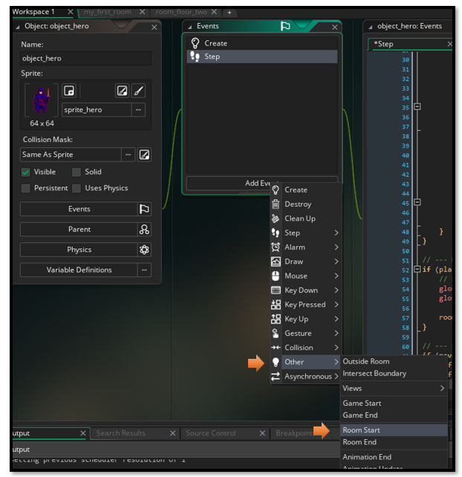
In the window that appears, we want to paste this code.
// Place hero at stored spawn point
// Place hero at stored spawn point
if (variable_global_exists("hero_spawn_x")) {
x = global.hero_spawn_x;
y = global.hero_spawn_y;
}

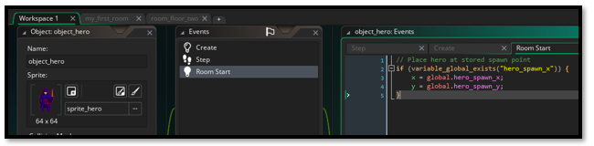

Door Linked Spawned System.
We are going to make the door smart. In this version of the code, we take the collision code away from the hero object, and instead place it into the the code for the door. In this lesson, we will teach the door where to send the hero into the next room.

Remove this section from the Hero Code.

if (place_meeting(x, y, Object_Door)) {
global.hero_spawn_x = 64;
global.hero_spawn_y = 128;
room_goto(room_floor_two);
}

Add a Collision Event to the Door
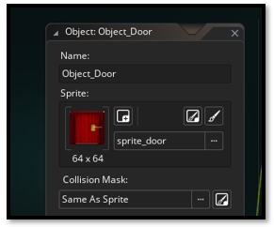
You want the collision to be with the object_hero
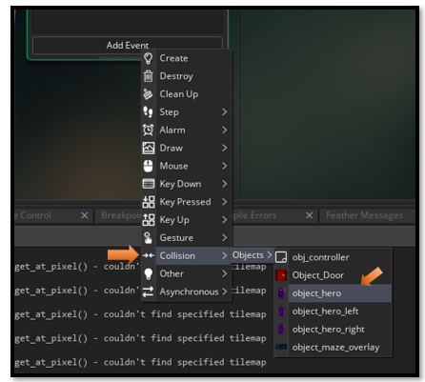

// Set spawn coordinates for hero in next room
global.hero_spawn_x = 64; // adjust as needed
global.hero_spawn_y = 128; // adjust as needed

// Go to the next room
room_goto(room_floor_two);

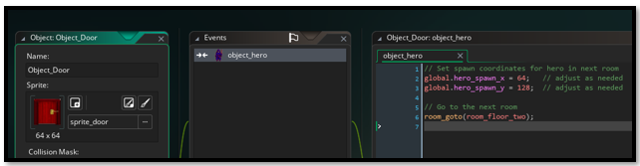

Update the Code to the Script
Remember that script code that we created in the Script folder? Well we will be updating that here in order for it to work with the next room.
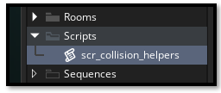
function wall_is_solid(x, y) {
var layer_name = "Wall_Tiles"; // update to match your wall layer name
var layer_id = layer_get_id(layer_name);

if (layer_id != noone) {
var tilemap_id = layer_tilemap_get_id(layer_id);
if (tilemap_id != noone) {
var tile = tilemap_get_at_pixel(tilemap_id, x, y);
return tile != 0;
}
}

// If no tilemap found, assume no collision
show_debug_message("⚠️ No wall tilemap found on layer: " + layer_name);
return false;
}
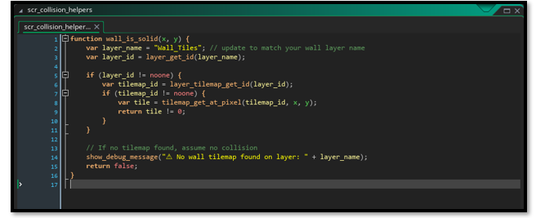

Test Code
Test your Game and Make sure the hero is in the next level and able to move.
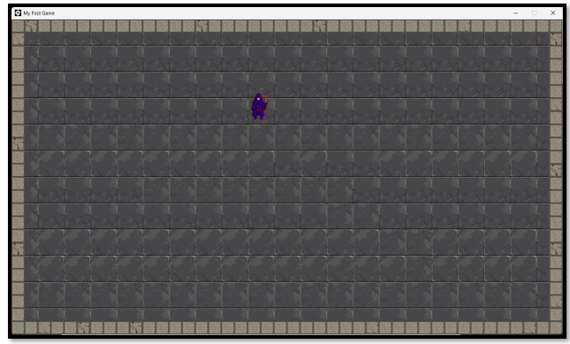

Room Initializer With a Door Generator
There are certain things that we want when a room generates. One of them is to have a door, and some other things, would be to make sure that things arrive in an order that is least likely to throw an error. In other things. certain things need to be in the room first for other things to work.
New Script
So, for this we are going to create another script.
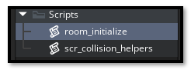

The Code for the room_initialize script
function room_initialize() {
// --- Reset ready flag ---
global.room_ready = false;
// --- Wall tilemap setup ---
var layer_name = "Wall_Tiles"; // update if needed
var layer_id = layer_get_id(layer_name);

if (layer_id != noone) {
var tilemap_id = layer_tilemap_get_id(layer_id);
if (tilemap_id != noone) {
global.wall_layer_id = layer_id;
global.tilemap_wall = tilemap_id;
global.wall_layer_x = layer_get_x(layer_id);
global.wall_layer_y = layer_get_y(layer_id);
global.wall_tile_w = tilemap_get_tile_width(tilemap_id);
global.wall_tile_h = tilemap_get_tile_height(tilemap_id);

global.room_ready = true;
} else {
show_debug_message("⚠️ No tilemap found on layer: " + layer_name);
}
} else {
show_debug_message("⚠️ No layer found named: " + layer_name);
}

// --- Door generator ---
// Example: place a door at bottom-right corner of the room
var door_x = room_width - 64; // adjust offset to align with tiles
var door_y = room_height - 64;

var door = instance_create_layer(door_x, door_y, "Instances", Object_Door);

// Assign destination info (customize per room)
door.room_target = room_floor_two; // target room
door.spawn_x = 64; // hero spawn X in target room
door.spawn_y = 128; // hero spawn Y in target room
}

Using this initialize Code in other objects
You might think that that is all we need to do to get things to work, but not quite. That is just the code that other elements in the game can use to get things working for them. So, this is sort of a 2, 3, 4, or how many other things that you need to use this code to start things up.
Note, Now remember you added the room start event to the hero already, but this time we need a room start even added to the controller object.

In the controller object
In your controller object’s Room Start Event, call:
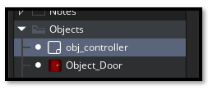
Remember when you add the Event, the room start event is found under Other in the list of Events.
room_initialize();

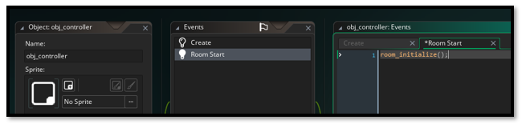

In the hero’s step event
You want to wrap the movement code for the hero with this code.
if (global.room_ready) {
// movement code
}

Here is the Full hero code, with the wrap included
// Movement input
var move_x = keyboard_check(vk_right) - keyboard_check(vk_left);
var move_y = keyboard_check(vk_down) - keyboard_check(vk_up);

var spd = 4;
var dx = move_x * spd;
var dy = move_y * spd;

// --- Attempt full diagonal move first ---
if (global.room_ready) {
if (dx != 0 || dy != 0) {
var nx_left = bbox_left + dx;
var nx_right = bbox_right + dx;
var ny_top = bbox_top + dy;
var ny_bottom = bbox_bottom+ dy;

var hit_diag =
wall_is_solid(nx_left, ny_top) ||
wall_is_solid(nx_right, ny_top) ||
wall_is_solid(nx_left, ny_bottom) ||
wall_is_solid(nx_right, ny_bottom);

if (!hit_diag) {
x += dx;
y += dy;
} else {
var hit_x =
wall_is_solid(bbox_left+dx, bbox_top) ||
wall_is_solid(bbox_right+dx, bbox_top) ||
wall_is_solid(bbox_left+dx, bbox_bottom) ||
wall_is_solid(bbox_right+dx, bbox_bottom);

if (!hit_x) {
x += dx;
}

var hit_y =
wall_is_solid(bbox_left, bbox_top+dy) ||
wall_is_solid(bbox_right, bbox_top+dy) ||
wall_is_solid(bbox_left, bbox_bottom+dy) ||
wall_is_solid(bbox_right, bbox_bottom+dy);

if (!hit_y) {
y += dy;
}
}
}

}

// --- Sprite switching ---
if (move_y < 0) sprite_index = sprite_hero_back;
else if (move_x > 0) sprite_index = sprite_hero_right;
else if (move_x < 0) sprite_index = sprite_hero_left;
else sprite_index = sprite_hero;

In your door object’s Collision Event with hero:
global.hero_spawn_x = spawn_x;
global.hero_spawn_y = spawn_y;
room_goto(room_target);

Remove the Door inside the Room
Oh, and since your room is now spawning its own doors, you will want to remove the one we placed into it manually.
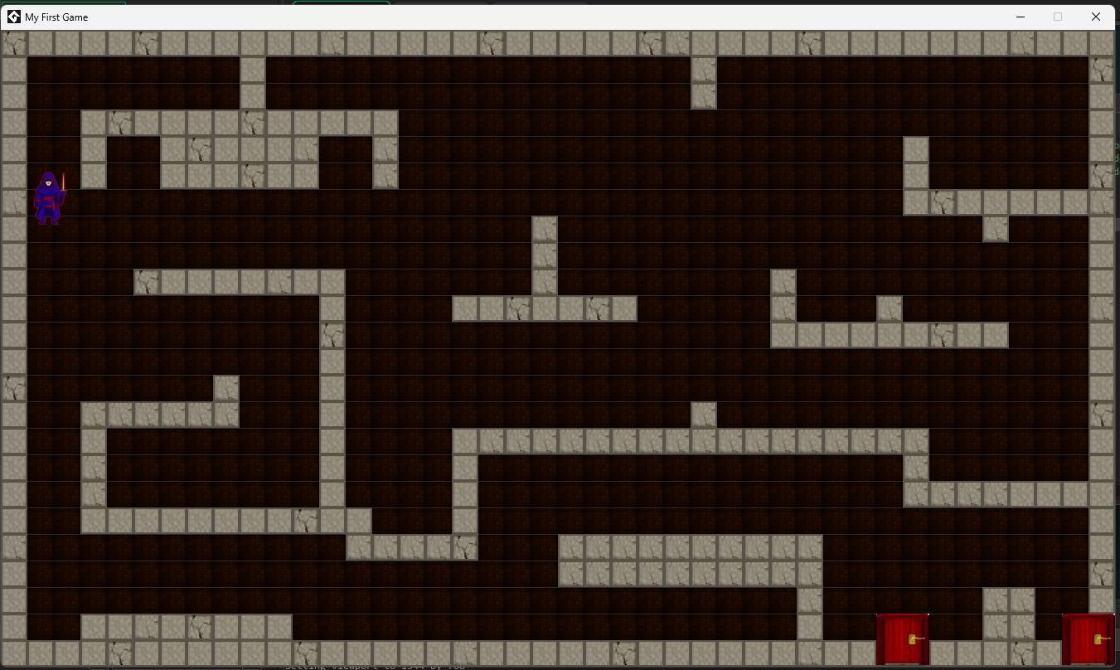
Now go to Room 2, after taking the door out of the first floor.
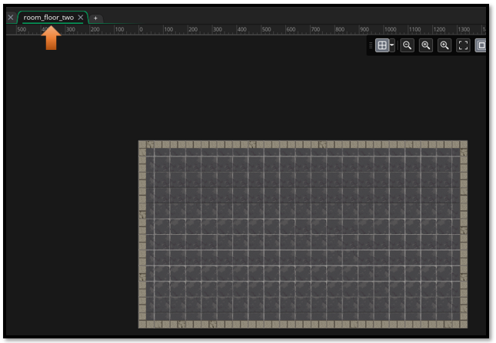
Now go to the Asset tab in the Asset Browser and pull the controller into the second floor. This controller must be added to every floor to work.
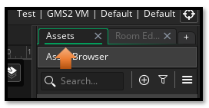
Now drag the controller object in.
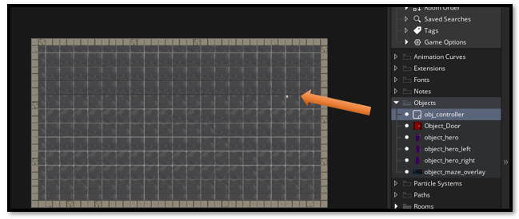

Test the Game
With the controller on both floors, when you run the game, you should be able to see the door automatically generate from the code, on each of the floors. It will be created in the lower right-hand corner of the ga me.
